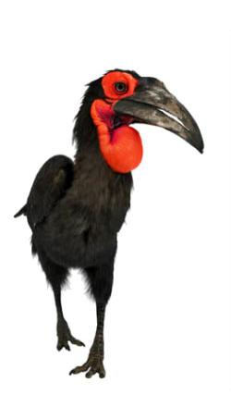Southern Ground-hornbill Taskforce Zimbabwe Report Sept 2023

^{Peter MAKHUSA}

The Southern Ground-hornbill (SGH) Bucorvus leadbeateri is distributed widely throughout the savannah and grasslands south of the moist equator. With its limited global range, the species is categorized as “Vulnerable” in South Africa. The SGH is of particular conservation concern in South Africa, where a dramatic reduction of its historical range occurred. According to Kemp, the SGH has experienced a decline in numbers in excess of 10% in the last three generations. Extensive research has been conducted in South Africa.

A national strategy planning workshop was conducted in 2020 to assess the status of the SGH in Zimbabwe. The multi-disciplinary stakeholders attending the workshop identified research priorities. In April 2021 a national distribution mapping exercise began as the primary research focus, using the methods of WhatsApp groups chats employed in South Africa. Sightings shared through these groups have been helpful in mapping the current distribution of SGH and showing gaps where further efforts need to be directed.

Since it is estimated that most of our populations occur on private land and in communal areas, i.e. areas with no formal protection, it is imperative that the species’ biological and ecological requirements, and constraints, be determined in these areas. The SGH is also a flagship species for the savannah biome and therefore serves as a valuable indicator species for this biome. From the above it is clear that a study on the biology and ecology of the species outside National Parks, private hunting concessions and farms is overdue. The first phase of study is a survey to determine the current distribution and status of the SGH in Zimbabwe. Preliminary results are being presented through the WhatsApp groups while considerable data is being accumulated.

Present and future threats to the species should be identified, quantified and management recommendations made as a matter of urgency.

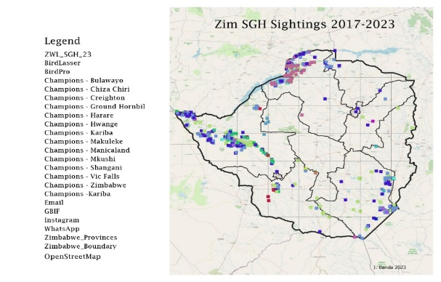
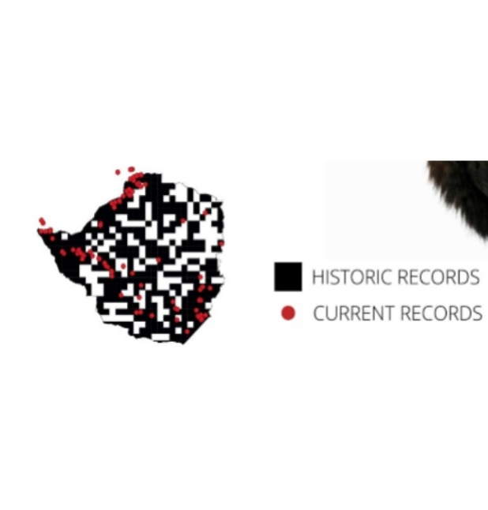
Our study indicates gaps in the Midlands, Mashonaland Central, Mashonaland East and Manicaland. Eight Champions groups have helped with continuous sightings, which have been key as we continue this exercise. A task force WhatsApp number has also helped as some people are not in the groups but can still send sightings straight to the number. About 15-20 sightings are received in a week. We have started a partnership with local tertiary undergraduates for a series of analyses of old data from special species which will help with the overlaying of old and new data.

In May 2023 we held a talk with the Mashonaland BLZ Branch (Avondale, Harare) which provoked people to think of ways to assist and help meaningfully towards saving the SGH. Following up on the talk one of the members, John, arranged another talk with a cultural club from Musukutwa, Bikita, who graced us with dance and music. The most interesting thing was that the SGH is an important bird in the Ngororombe (kwaira) dance as the drums play and sound like the call of the bird itself. This shows that the bird is of high value to the people and it is well respected in the area. An invitation has been extended for us to visit the village and share more with the villagers.

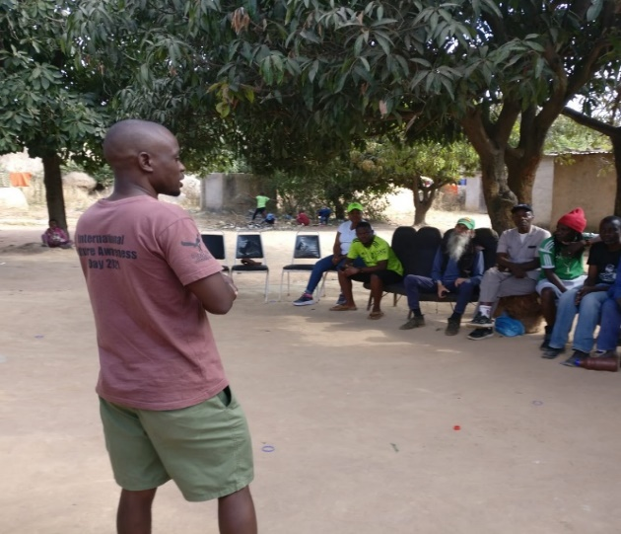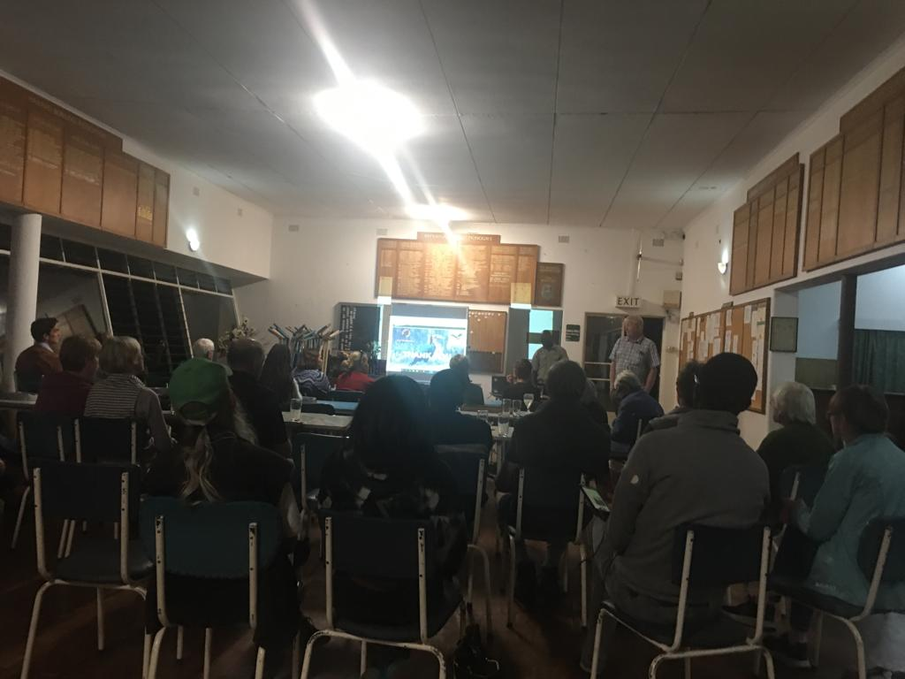

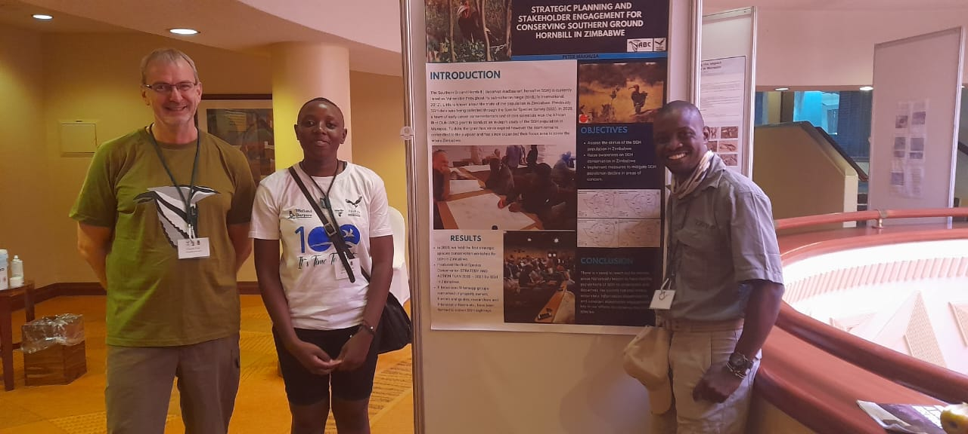

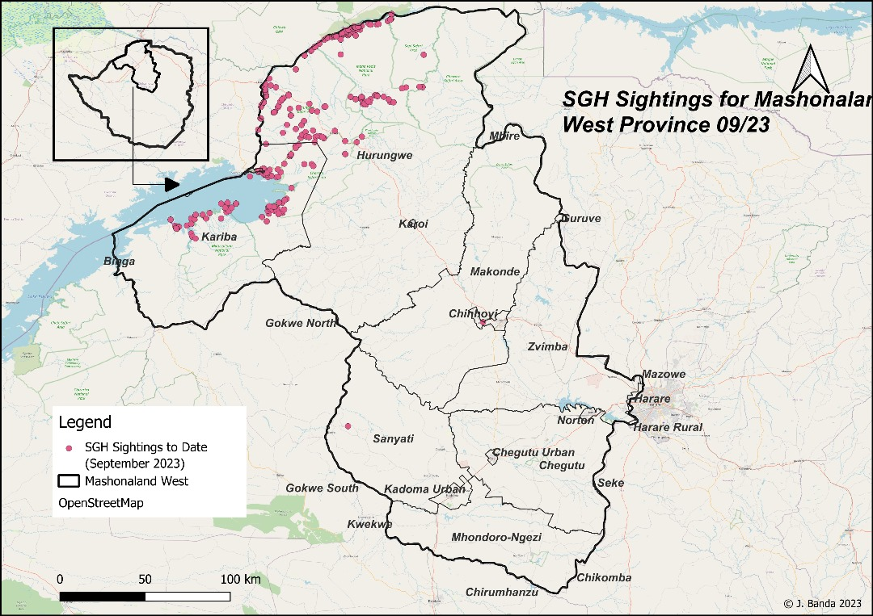

We would like to congratulate the Kariba group, which has won the best group award twice this year in both Zimbabwe and South Africa for the most active and consistent sightings group. May you continue and may the fire catch on with the other groups. We have added three new groups, namely Bikita, Midlands and Matopos to make a total of 14 WhatsApp groups and look to expand this to all the historical territories.

Conclusions
The results of our study provided valuable insights into the present distribution of the species in Zimbabwe and highlighted several challenges and opportunities that can be used to ensure the long-term survival of the species.
These insights have informed current priorities for SGH conservation in Zimbabwe, which are:
- Continued annual monitoring of the status and distribution of SGH across the country.
- Determine the group size and, where possible, the group structure, home range, breeding site, and productivity of each group.
- Determine and quantify the threats to the survival of the SGH in the region.
- Determine the beliefs and extent of use of the SGH in the traditional medicine trade.
- Re-establish and continue the Matopos breeding survey which began in 2007 (contact was made with Mr. Bruce Mcdonald).
- Data analysis has begun in partnership with NUST and Miss C Nyathi is helping with cleaning the of data from 2007-2021.

Overall, the study provided valuable information on the status and distribution of the species, especially in parks and wildlife sanctuaries. The long-term survival of the SGH depends on its interaction with man and his environment. Citizen scientist play a major role, and given the right knowledge, the conservation and survival of the species is going to be a success.

Calendar of activities
Date | Activity | Location
TBA | Community Outreach | Bikita\Buhera
September | Education and awareness campaign | Kariba\Dete
TBA | Community outreach | Matusadhonha
Oct | Community Re-engagement | Matopos

